|  |
| --- |
|  |
| GFI_logo1 |

**DDIC Risk Assesment**

**EXTGFI0188**

*Technical Analysis*

INDEX

1. Document revision history 3

1. REFERENCES 3

2. PURPOSE 3

3. BENEFITS 3

4. SAP artifacts 3

4.1 Tables 4

4.2 ABAP Objects 4

4.2.1 Selection Screen 5

4.2.1.1 Block A: Search Criteria 5

4.2.1.2 Block B: Communications Fields 5

4.2.2 Use of class ZCL\_DDIC\_ANALYSIS 6

4.2.3 Outputs: 7

4.2.3.1 Emails 7

# Document revision history

|  |  |  |  |  |
| --- | --- | --- | --- | --- |
| **Version** | **Date** | **Changed By** | **Reviewed By** | **Comments** |
| 1.0 | 26/05/2019 | GFI | Adrián Romero-Dapena | Report based on Class ZCL\_DDIC\_ANALYSIS |
|  |  |  |  |  |
|  |  |  |  |  |

1. REFERENCES

**Business Owners contacted:** Stuart Dinnen, Klara Falcone.

1. PURPOSE

The purpose of this development is to build a report that aims at presenting and sharing the outputs generated by class ZCL\_DDIC\_ANALYSIS.

The output of this class (a DDIC risk assessment fully automated) will be displayed in an ALV screen and sent by email with several formats depending on the stakeholder that we are interested to inform.

1. BENEFITS

The automation of the DDIC risk assessment communications will make much easier two two key points:

1. The communications with DB2 Teams from Transports Team
2. The analysis of the DDIC objects for the weekend release:
   1. From the Transports Team point of view by having a fully detailed list of objects
   2. From the Go Live Meeting Team by having a list of the changes with a risk categorisation
3. SAP artifacts

New objects which are going to be delivered:

* In SOS:
  + Report: ZRTT\_SOP\_DDIC
  1. Tables

No database tables will be needed for this automation.

* 1. ABAP Objects

Below, there is an UML chart to relate the main objects of this development. The main object is the class ZCL\_DDIC\_ANALYSIS which makes use of the interface ZIF\_DDIC\_ANALYSIS for all the Types and Constants which are used among the Public and Private methods.

The class calls through RFC connection a FM in the target systems to pull the raw DDIC details that will be later categorised.

The main FM ZFM\_DDIC\_ANALYSIS calls within the source system another FM ZFM\_CRITICAL\_BATCH\_ANALYSIS that serves the purpose of providing the Critical Objects used by batches (going only one level in depth).

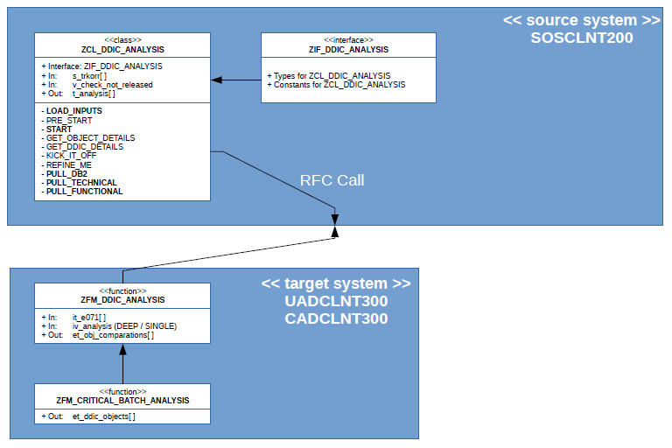

By using this class, providing the inputs, we will be able to get an output that we can work with and other pieces of information that we will recycle for the ALV screen.

* + 1. Selection Screen

For the selection screen, we are going to have 2 main blocks:

1. The block for the search criteria of the DDIC objects
2. The block to shape the email communications
   * + 1. Block A: Search Criteria

This block will have 4 possible inputs:

* **The TR/TOCs to be analyse:** 
  + Range of TRKORR: E070-TRKORR
  + Default value: None
  + Validations: None
* **The Planned to Production Delivery Date in HPALM:**
  + Range of Dates: ZXX\_HPALM\_DATA-ZPLANNED\_DATE
  + Defalult value: The current Sunday of the week
  + Validations: None
* **The Requirement IDs of the Changes in HPALM:** 
  + Range of Requirement IDs: ZXX\_HPALM\_DATA-ZREQ\_ID
  + Default value: None
  + Validations: None
* **The Release Status of the Changes in HPALM:** 
  + Range of Release Status: ZXX\_HPALM\_DATA-ZREL\_STATUS
  + Default value: None
  + Validations: None

Also, a checkbox will control whether we want to analyse only TRKORR’s that have been released or all of them [Released & Not Released]. By default, the checkbox will be marked as True.

* + - 1. Block B: Communications Fields

This block will have 5 different sections:

1. Email options:
   1. Checkbox to send email
   2. Checkbox to include dates in Subject
   3. Checkbox to add DDIC detailed breakdown as attachment
2. Email inputs:
   1. **Sender**:
      1. Type: ADR6-SMTP\_ADDR
      2. Input is mandatory if checkbox to send email is marked
      3. Default value: GFI\_Transports@gfi.es
      4. Validations:
         1. String has to contain only one “@”
         2. String has to contain – at least – one “.”
         3. Strinng cannot have any punctuation characters apart from “.”
   2. **Receivers**:
      1. Type: /IWFND/EPM\_EMAIL\_ADDRESS
      2. Input is mandatory if checkbox to send email is marked
      3. Validations: For each of the input email addresses
         1. String has to contain only one “@”
         2. String has to contain – at least – one “.”
         3. Strinng cannot have any punctuation characters apart from “.”
3. Receivers Contents:
   1. Radio button: DB2
   2. Radio button: Functional Team
   3. Radio button: Technical Team
4. DB2 Formatting:
   1. Block 4A: Release Type
      1. Emergency
      2. Urgent
      3. Weekend
   2. Block 4B: Weekend Type
      1. FIS Stop
      2. Non-FIS Stop

See below, the criteria to follow to hide/show blocks depending on which option is marked:

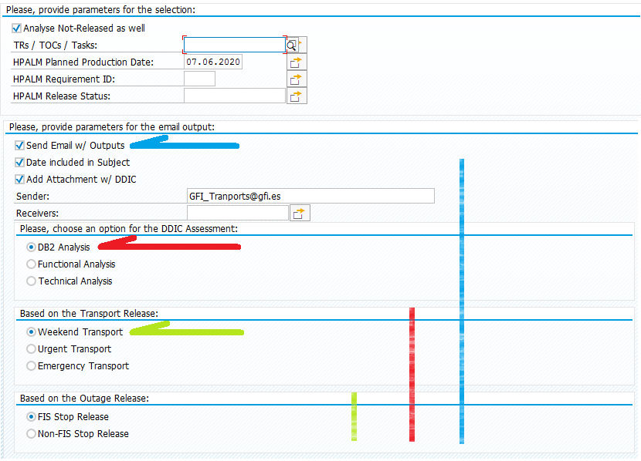

* + 1. Use of class ZCL\_DDIC\_ANALYSIS

With the inputs of the first block you will have to provide them to class ZCL\_DDIC\_ANALYSIS in order to allow the assessment to work.

Below, you can see the sequence of use of this class:

*\* Declare the object:*

  DATA**:**o\_analysis TYPE REF TO zcl\_ddic\_analysis**.**  
*\* Create the object:*  
  CREATE OBJECT o\_analysis**.**

*\* Provide inputs:*

o\_analysis->load\_inputs**(**ir\_trkorr  **=**s\_trkorr[]  
                             ir\_requid  **=**s\_reqid[]  
                             ir\_planned **=**s\_datum[]  
                             ir\_status  **=**s\_status[] **).**

*\* Start to the DDIC analysis:*  
o\_analysis->start**( ).**

Once done, the class ZCL\_DDIC\_ANALYSIS has a set of attribute tables and methods that we will be using for our outputs.

* + 1. Outputs:
       1. Emails

Depending on the option chosen in the selection screen [ DB2 Team, Functional Team, Technical Team ] you can use different methods of class ZCL\_DDIC\_ANALYSIS to provide you with the outputs that will be either attachments or embedded body tables.

All email will have as attachement the full list of DDIC objects with the assessment for all of them (except if in selection screen the option of not adding attachements is marked).

* + - * 1. DB2 Team Email:
* **Subjects**:
  + When Emergency Release: DDIC Analysis: Emergency Release DD.MM.YYYY
  + When Urgent Release: DDIC Analysis: Urgent Release DD.MM.YYYY
  + When Weekend Release
    - FIS Stop: DDIC Analysis: Weekend Release [FIS Stop]
    - Non-FIS Stop: DDIC Analysis: Weekend Release [Non-FIS Stop]
* **Body Table**:
  + Call method: <lfs\_t\_data> **=**me->o\_analysis->pull\_db2**( ).**
  + Place the returning values in a generic field-symbol
  + Create a header according to the outputs stored in the field-symbol
* **Body Text**: It will be changing depending on the release.
  + Top Text:
    - **Emergency**:

Hi DB2 Team,   
  
The below transport(s) have been approved for promotion to Production**: Immediately** ( Approval is attached )

* + - **Urgent**:

Hi DB2 Team,   
  
The below transport(s) have been approved for promotion to Production**: Tonight** (Friday morning. Approval is attached )

* + - **Weekend**:

Hi DB2 Team,   
  
The below transport(s) have been approved for promotion to Production**: This Weekend** ( Sunday morning. Approval is attached )

* + Bottom Text: Quite similar for all of them

**Could you, please, analyse them and reply back to us?**   
  
**Please, notice:** Any object with (\*\*\*) beside its Risk Level, means that either it has a considerable number of entries in Production or that the analysis has pointed out a lot of references of use in Development Environment.   
  
Thanks.   
  
Regards,   
  
GFI Transports Team

\_\_\_\_\_\_\_\_\_\_\_\_\_\_\_\_\_\_\_\_\_\_\_\_\_\_\_\_\_\_\_\_\_\_\_\_\_\_\_\_\_\_\_\_\_\_\_\_\_\_\_\_\_

**\*\*\*IMPORTANT\*\*\***

Please, note that for the FIS Stop weekends emails sent to the DB2 Team the body table will only show object with Risk Level = [ “Very High”, “High” ] and also the bottom text will be slightly different since we will be just informing them about the objects, but not asking for a reply from their side:

**Since this is a FIS Stop Release, the objects above are only for information purposes. No need for analysis.**   
  
**Please, notice:** Any object with (\*\*\*) beside its Risk Level, means that either it has a considerable number of entries in Production or that the analysis has pointed out a lot of references of use in Development Environment.   
  
Thanks.   
  
Regards,   
  
GFI Transports Team

* + - * 1. Functional Team Email:
* **Subject**: DDIC Analysis: Functional Assessment DD.MM.YYYY
* **Body Table**:
  + Call method: <lfs\_t\_data> **=**me->o\_analysis->pull\_functional**( ).**
  + Place the returning values in a generic field-symbol
  + Create a header according to the outputs stored in the field-symbol
* **Body Text**:
  + **Top Text:**

Hi All,   
  
Find below the list of changes with a rough overview of their potential DDIC risk level.   
  
For further details, you can check the attachement, which has a full breakdown for each object with DDIC.

* + **Bottom Text:**

Regards,   
  
GFI Transports Team

\_\_\_\_\_\_\_\_\_\_\_\_\_\_\_\_\_\_\_\_\_\_\_\_\_\_\_\_\_\_\_\_\_\_\_\_\_\_\_\_\_\_\_\_\_\_\_\_\_\_\_\_\_

**\*\*\*IMPORTANT\*\*\***

The body table will have to be highlighted in different colors when Risk Level = [ “Very High”, “High” ] as per example below:

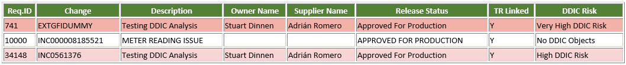

This can bee easly achived by using the piece of code below that make use of class ZCL\_EMAIL\_COMMUNICATIONS to send the emails:

*\* For Functional analysis, do highlight the dangerous changes:*

  IF r\_func EQ abap\_true**.**  
    LOOP AT <lfs\_t\_data> ASSIGNING <lfs\_s\_data>**.**  
      ADD 1 TO lv\_row\_counter**.**  
      ASSIGN COMPONENT 'DDIC\_RISK' OF STRUCTURE <lfs\_s\_data> TO <lfs\_v\_data>**.**  
       IF <lfs\_v\_data> IS ASSIGNED AND <lfs\_v\_data> CS 'Very High DDIC Risk'**.**  
         lo\_email->change\_layout\_template**(**iv\_sort **=**1  
                                           iv\_row  **= (**lv\_row\_counter + 1 **)**  
                                iv\_bg\_color **=**zif\_email\_types=>c\_row\_1\_red **).**  
  
       ELSEIF <lfs\_v\_data> IS ASSIGNED AND <lfs\_v\_data> CS 'High DDIC Risk'**.**  
         lo\_email->change\_layout\_template**(**iv\_sort **=**1  
                                           iv\_row  **= (**lv\_row\_counter + 1 **)**  
                                iv\_bg\_color **=**zif\_email\_types=>c\_row\_0\_red **).**  
  
          ENDIF**.**  
        ENDLOOP**.**  
      ENDIF**.**

* + - * 1. Technical Team Email:
* **Subject**: DDIC Analysis: Technical Assessment DD.MM.YYYY
* **Body Table**:
  + Call method: <lfs\_t\_data> **=**me->o\_analysis->pull\_technical**( ).**
  + Place the returning values in a generic field-symbol
  + Create a header according to the outputs stored in the field-symbol
* **Body Text**:
  + **Top Text:**

Hi All,   
  
Find below the full breakdown of the DDIC Risk Assessment:

* + **Bottom Text:**

Regards,   
  
GFI Transports Team